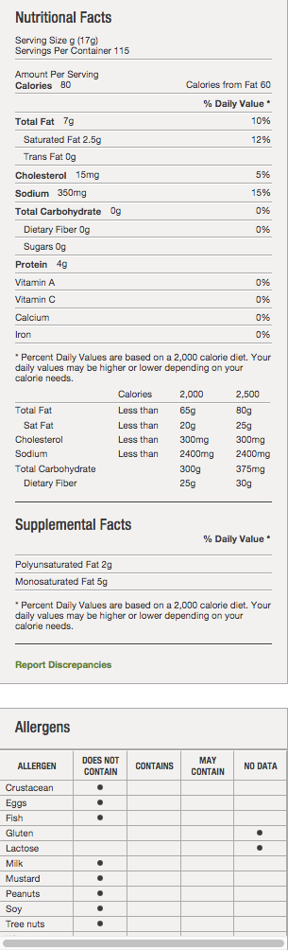
BACON
Product Description Additional Description EVERYTHING'S BETTER WITH BACON! TRY THESE PATUXENT FARMS PREMIUM CENTER CUT BACON SLICES, ALL NATURAL APPLEWOOD SMOKED FOR A SWEETER FLAVOR. THEY'RE COOKED, PACKED AND READY TO ADD SIZZLE TO YOUR MENU. Ingredients PORK, WATER, SEA SALT, CANE SUGAR, NATURAL FLAVORS. Manufacturer Information PATUXENT FARMS Manufacturer Product #: 232431 Preparation & Cooking Preparations and Cooking Instructions OVEN BAKEABLE OR MICROWAVE. LIGHTLY WARM, BRINGING JUICES AND COLOR OUT OF PRODUCT. HEATING TOO LONG WILL SHRINK BACON FURTHER. Handling Instructions KEEP REFRIGERATED FOR UP TO 2 WEEKS. Serving Suggestions: MADE PRIMARILY FOR SANDWICH APPLICATIONS. ALLOWS EXACT PORTIONS AND COST CONTROL. GREAT TOPPING FOR BURGERS, WRAPPING CHICKEN, BEEF TENDERLOIN, OR USE COOKED BACON ON SALADS OR BAKED POTATOES, AS A SIDE DISH, BUFFETS, CONTINENTAL BREAKFAST, SANDWICHES, GARNISH, OR RECIPE INGREDIENT IN QUICHE OR A FRITTATA. ANY APPLICATION WHERE BACON IS PARAMOUNT SUCH AS OPEN FACED SANDWICHES.

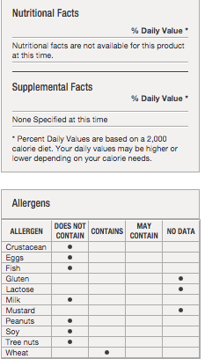
BAGEL
Product Description Additional Description FULLY BAKED 2.3 OZ. SLICED AUTHENTIC NEW YORK STYLE BOILED BAGEL WITH A SHINY CRISP CRUST AND DENSE CHEWY INTERIOR. GREAT NEUTRAL FLAVOURFUL MAKING IT IDEAL FOR MULTIPLE APPLICATIONS. APPROXIMATELY 3.9" IN DIAMETER. 12 SLEEVES OF 6 BAGELS EACH PER CASE. Ingredients ENRICHED WHEAT FLOUR (WHEAT FLOUR, MALTED BARLEY FLOUR, NIACIN, REDUCED IRON, THIAMIN MONONITRATE, RIBOFLAVIN, FOLIC ACID), WATER, DEXTROSE, SALT, YEAST, WHEAT GLUTEN, FERMENTED RYE FLOUR, CORNMEAL, MALTED BARLEY FLOUR, CALCIUM PROPIONATE (PRESERVATIVE), MODIFIED CORNSTARCH, DOUGH CONDITIONERS (ENZYMES, L-CYSTEINE). Manufacturer Information HILLTOP HEARTH Manufacturer Product #: 847066
BEANS, PINTO
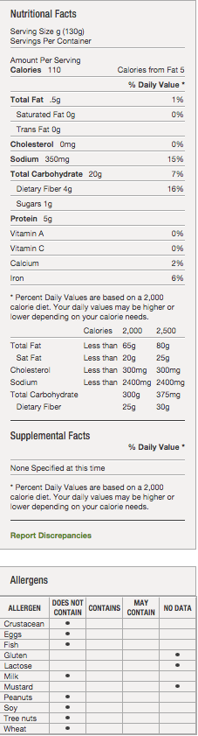
Product Description-Additional Description
PINTO BEANS BRING CHOLESTEROL FREE, FIBER-RICH FLAVOR TO YOUR MENU. YOU CAN COUNT ON THESE USDA GRADE A BEANS FOR SIZE, TEXTURE AND COLOR.
Ingredients
PREPARED PINTO BEANS, WATER, SALT, CALCIUM CHLORIDE, DISODIUM EDTA ADDED FOR COLOR RETENTION
Manufacturer Information
DEL PASADO
Manufacturer Product #: 173113

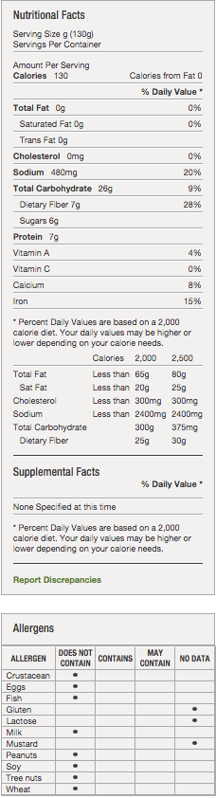
BEANS, VEGETARIAN
Product Description-Additional Description
MEETS/EXCEEDS FOODSERVICE INDUSTRY STDS-DISTINCTLY DIFFERENT. USDA GRADE A FANCY WHITE BEANS ARE USED FOR THIS PRODUCT. BEANS WILL BE FIRM, YET TENDER IN A RICH RED TOMATO SAUCE.NATURALLY HEALTHY, HIGH IN DIETARY FIBER, TRANS FAT FREE.
Ingredients
WHITE BEANS, WATER, SUGAR, HIGH FRUCTOSE CORN SYRUP, TOMATO PASTE, SALT, OLEORESIN PAPRIKA, DEXTROSE, ONION POWDER, GARLIC POWDER, AND NATURAL FLAVORINGS.
Manufacturer Information
MONARCH-D
Manufacturer Product #: 171340

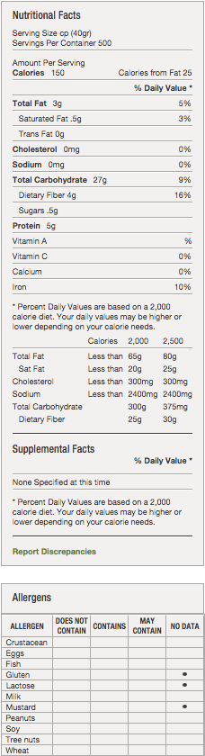
CEREAL-OATMEAL ROLLED
Additional Description
THE GOODNESS OF OATS
Ingredients
100% WHOLE GRAIN ROLLED OATS
Manufacturer Information
MOM BRANDS CO LLC DBA POST CON
Manufacturer Product #: 04650

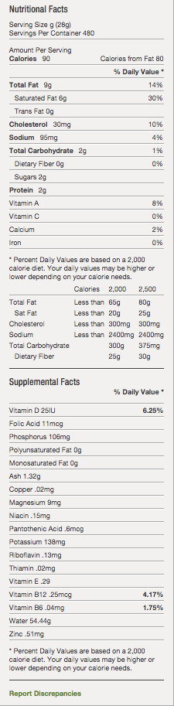
CHEESE
Product Description Additional Description HIGHER BUTTERFAT CONTENT THAN NEUFCHATEL. SPREADS AND MIXES EASILY WITH JAMS OR PRESERVES. COMBINES WELL WITH CUCUMBER, WATERCRESS, TOMATOES OR SLICED OLIVES. Ingredients PASTEURIZED MILK AND CREAM, CHEESE CULTURE, SALT, STABILIZERS (CAROB BEAN AND/OR XANTHAN AND/OR GUAR GUMS). Manufacturer Information GLENVIEW FARMS Manufacturer Product #: 073673

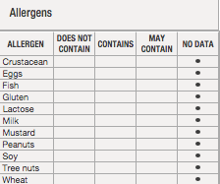

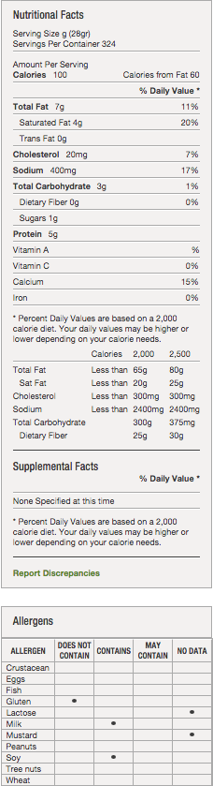
Cheese, American
Additional Description
4/5# Process American Yellow Cheese Product 160V Slice
Ingredients
CULTURED MILK AND SKIM MILK, WHEY, SALT, SODIUM CITRATE, MODIFIED FOOD STARCH, COLOR ADDED (IF COLORED), SODIUM PHOSPHATE, SORBIC ACID (PRESERVATIVE), LACTIC ACID, ENZYMES, SOY LECITHIN (NON-STICKING AGENT)
Manufacturer Information
BONGARDS CREAMERIES
Manufacturer Product #: 10162

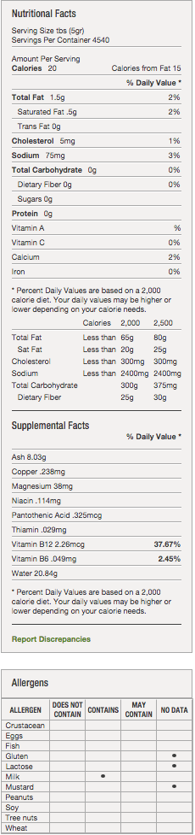
CHEESE, PARMESAN AND IMITATION BLEND
Additional Description
65% PARMESAN & 35% IMITATION PARMESAN.
Ingredients
INGREDIENTS: PARMESAN CHEESE: (PASTEURIZED PART-SKIM COW?S MILK, CHEESE CULTURES, SALT, ENZYMES), IMITATION PARMESAN CHEESE (MODIFIED FOOD STARCH, CELLULOSE, SOY OIL, WATER, PALM OIL, CASEIN, NATURAL FLAVORING, SALT, SODIUM CASEINATE, SODIUM PHOSPHATE, LACTIC ACID, SORBIC ACID, SODIUM ALGINATE, ARTIFICIAL COLOR), POWDERED CELLULOSE ADDED TO PREVENT CAKING, POTASSIUM SORBATE ADDED TO PROTECT FLAVOR.
Manufacturer Information
WINONA FOODS INC
Manufacturer Product #: 13179

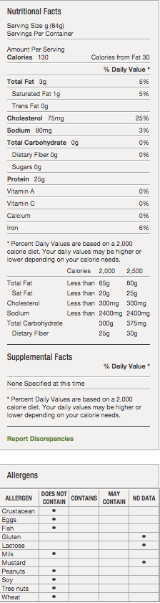
CHICKEN-DICED
Product Description- Additional Description
IQF HALF INCH DICED, FULLY COOKED 10% WHITE AND 90% DARK FOWL MEAT. FOWL HAS STRONGER CHICKEN FLAVOR THAN FRYER MEAT. USING FULLY COOKED SAVES LABOR, TIME, AND REDUCES FOOD SAFETY RISKS INHERENT IN HANDLING RAW. ALL NATURAL.
Ingredients
CHICKEN MEAT.
Manufacturer Information
PATUXENT FARMS
Manufacturer Product #: 464574

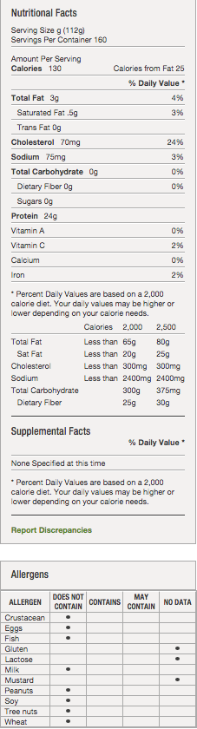

GRILLED CHICKEN BREAST
Ingredients
CHICKEN BREAST FILLETS WITH RIB MEAT, WATER, MODIFIED FOOD STARCH, SALT, SODIUM PHOSPHATES, POTASSIUM CHLORIDE, MALTODEXTRIN, DEXTROSE, GRILL FLAVOR (MALTODEXTRIN, PARTIALLY HYDROGENATED COTTONSEED AND SOYBEAN OIL, MODIFIED FOOD STARCH, CORN SYRUP SOLIDS), DEHYDRATED ONION, DEHYDRATED GARLIC, YEAST EXTRACT, FLAVORINGS, GRILL FLAVOR (PARTIALLY HYDROGENATED SOYBEAN AND COTTONSEED OIL), NATURAL SMOKE FLAVOR, SPICES. GLAZED WITH: WATER, MODIFIED FOOD STARCH, CARAMEL COLOR.
Manufacturer Information
KOCH FOODS INC
Manufacturer Product #: 88575

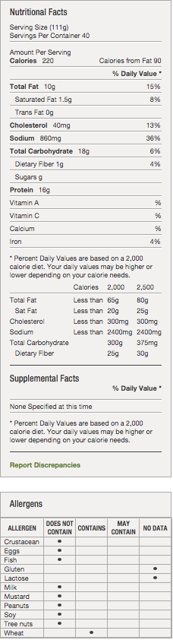
CHICKEN TENDERS
Additional Description
FZN, 12% SOL ADD, PRFRD. THIS PORTIONED TENDERLOIN HAS A GOLDEN FLAVOR WITH CLASSIC BREADING FOR AN EVEN TEXTURE AND UNIFORM APPEARANCE. LIGHTLY PEPPERED, THIS FRITTER OFFERS TASTY VISUALS IN EVERY BITE. TRG SZ 1.5 - 2.5OZ. TRG PC CT 76-86.
Ingredients
CHICKEN, CONTAINS UP TO 12% OF A SOLUTION OF WATER, MODIFIED FOOD STARCH, SALT, SODIUM PHOSPHATES. BREADED WITH: WHEAT FLOUR, WATER, MODIFIED CORN STARCH, SALT, YELLOW CORN FLOUR, CONTAINS 2% OR LESS OF THE FOLLOWING: EXTRACTIVES OF TUMERIC, GARLIC POWDER, HYDROLYZED CORN GLUTEN, LEAVENING (SODIUM BICARBONATE, SODIUM ALUMINUM PHOSPHATE, MONOCALCIUM PHOSPHATE), MALTODEXTRIN, NATURAL FLAVOR, ONION POWDER, SPICES, WHEAT GLUTEN, YEAST EXTRACT. BREADING SET IN VEGETABLE OIL.
Manufacturer Information
PATUXENT FARMS
Manufacturer Product #: 483285

CHOCOLATE CHIP COOKIES
ENRICHED FLOUR (WHEAT FLOUR, NIACIN, REDUCED IRON, THIAMIN MONONITRATE [VITAMIN B1], RIBOFLAVIN [VITAMIN B2], FOLIC ACID), SEMISWEET CHOCOLATE (SUGAR, CHOCOLATE, COCOA BUTTER, DEXTROSE, SOY LECITHIN, ARTIFICIAL FLAVOR, NONFAT MILK), VEGETABLE OIL (SOYBEAN AND PALM OIL WITH TBHQ FOR FRESHNESS), SUGAR, HIGH FRUCTOSE CORN SYRUP, CONTAINS TWO PERCENT OR LESS OF SALT, LEAVENING (BAKING SODA, MONOCALCIUM PHOSPHATE), ARTIFICIAL FLAVOR.
Manufacturer Information- MONARCH - Manufacturer Product #: 514064

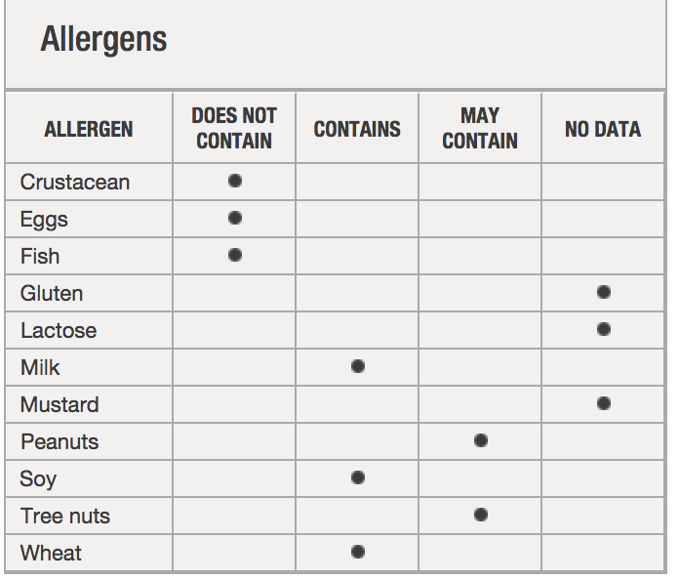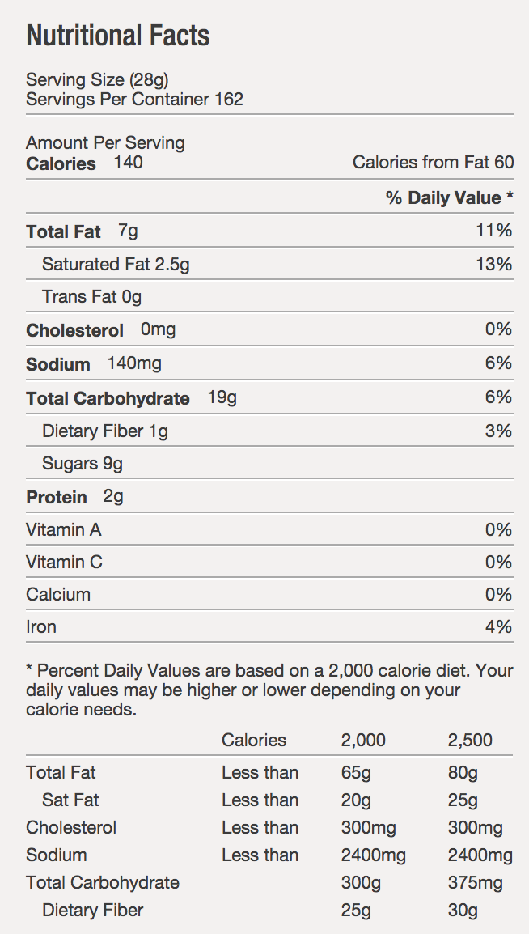

SUGAR COOKIES
ENRICHED FLOUR (WHEAT FLOUR, NIACIN, REDUCED IRON, THIAMIN MONONITRATE [VITAMIN B1], RIBOFLAVIN [VITAMIN B2], FOLIC ACID), SUGAR, VEGETABLE OIL (SOYBEAN AND PALM OIL WITH TBHQ FOR FRESHNESS), CONTAINS TWO PERCENT OR LESS OF SALT, LEAVENING (BAKING SODA, MONOCALCIUM PHOSPHATE), ARTIFICIAL FLAVOR, SOY LECITHIN.
Manufacturer Information - MONARCH - Manufacturer Product #: 514093

CORN CHIPS- FRITOS
GLUTEN FREE!
FRITOS CORN CHIPS HAVE CLASSIC CORN TASTE AND HEARTY TEXTURE THAT GOES CRUNCH. AN UNMISTAKABLE ALL-AMERICAN ORIGINAL, FRITOS ARE PERFECT FOR DIPPING OR FOR USE IN YOUR OWN SOUTHWESTERN RECIPE CREATION.
INGREDIENTS: CORN, CORN OIL, AND SALT.
Manufacturer Information - FRITO LAY/ QUAKER/ TROPICANA - Manufacturer Product #: 12248

DOUGH-COOKIE, CHOC. CHIP
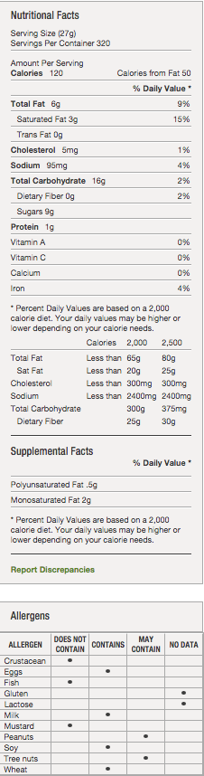
Product Description-Additional Description
HARVEST VALUE CHOCOLATE CHIP IS MADE WITH A MARGARINE AND SHORTENING BLEND WITH CONSERVATIVE INCLUSION PORTIONS TO PROVIDE A COOKIE LINE SOLUTION FOR COST SENSITIVE CUSTOMERS.
Ingredients
ENRICHED BLEACHED FLOUR (BLEACHED WHEAT FLOUR, MALTED BARLEY FLOUR, NIACIN, IRON, THIAMIN MONONITRATE, RIBOFLAVIN, FOLIC ACID),SUGAR, PALM AND PALM KERNEL OIL, SEMI-SWEET CHOCOLATE CHIPS (SUGAR, UNSWEETENED CHOCOLATE, DEXTROSE, COCOA BUTTER, SOY LECITHIN, VANILLA EXTRACT), MARGARINE (PALM OIL, WATER, SOYBEAN OIL, CONTAINS 2% OR LESS OF: SALT, MONO- AND DIGLYCERIDES, NATURAL FLAVORS [INCLUDES MILK], CITRIC ACID, VITAMIN A PALMITATE ADDED, BETA CAROTENE [COLOR]), WATER, EGGS, DEXTROSE, CONTAINS 2% OR LESS OF: MOLASSES, COCOA PROCESSED WITH ALKALI,WHEAT STARCH, BAKING SODA, SALT, NATURAL AND ARTIFICIAL FLAVOR, SORBITAN MONOSTEARATE, POLYSORBATE 60, SOY LECITHIN.
Manufacturer Information
HARVEST VALUE
Manufacturer Product #: 685997

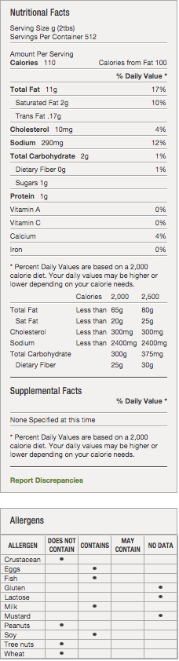
DRESSING- Italian, with Caesar and Romano cheese
Product Description-Additional Description
CREAMY TAN COLORED SALAD DRESSING WITH TYPICAL CAESAR FLAVORS OF PARMESAN CHEESE, ROMANO CHEESE, GARLIC, LEMON, ANCHOVY AND VISIBLE BLACK PEPPER. SHELF STABLE PRODUCT
Ingredients
SOYBEAN OIL, VINEGAR, WATER, ROMANO CHEESE (PASTEURIZED MILK, CHEESE CULTURES, SALT, ENZYMES), PARMESAN CHEESE (PASTEURIZED MILK, CHEESE CULTURES, SALT, ENZYMES), EGG YOLK, HIGH FRUCTOSE CORN SYRUP, CONTAINS LESS THAN 2% OF: SALT, SUGAR, MODIFIED FOOD STARCH, GARLIC, SPICES, NATURAL FLAVOR, XANTHAN GUM, ANCHOVY (FISH), LACTIC ACID, POLYSORBATE 60, ONION, SODIUM BENZOATE AND CALCIUM DISODIUM EDTA AS PRESERVATIVES, MOLASSES, MALTODEXTRIN, CORN SYRUP, CARAMEL COLOR, HYDROLYZED SOY PROTEIN, TAMARIND, YEAST EXTRACT, SUNFLOWER OIL.
Manufacturer Information
MONARCH
Manufacturer Product #: 254834

Ingredients
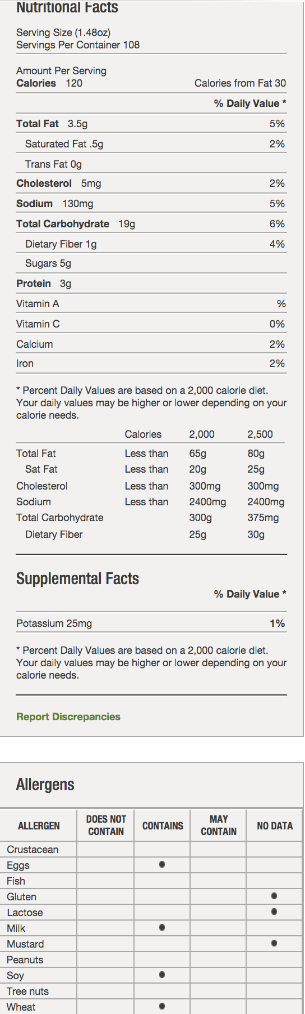
FRENCH TOAST STICKS- *Wednesday of PreWeek

WHOLE WHEAT BREAD (WHOLE WHEAT FLOUR, WATER, ENRICHED WHEAT FLOUR [FLOUR, MALTED BARLEY FLOUR, NIACIN, REDUCED IRON, THIAMINE MONONITRATE, RIBOFLAVIN, FOLIC ACID], SUGAR, WHEAT GLUTEN, YEAST, SALT, SOYBEAN OIL, MONO AND DIGLYCERIDES, CALCIUM PROPIONATE (PRESERVATIVE), DATEM, CALCIUM SULFATE, CITRIC ACID, SOY LECITHIN, GRAIN VINEGAR, POTASSIUM IODATE), WATER, WHOLE WHEAT BATTER (WHOLE WHEAT FLOUR, SUGAR, ENRICHED WHEAT FLOUR [ENRICHED WITH NIACIN, REDUCED IRON, THIAMINE MONONITRATE, RIBOFLAVIN, FOLIC ACID], DEXTROSE, EGGS, YELLOW CORN FLOUR, CORN SYRUP SOLIDS, NATURAL FLAVOR, MODIFIED CORN STARCH, SALT, LEAVENING (SODIUM ALUMINUM PHOSPHATE, SODIUM BICARBONATE), NONFAT MILK, SPICE, ARTIFICIAL FLAVOR, MODIFIED CELLULOSE GUM, SPICE EXTRACTIVE), COATING (ENRICHED WHEAT FLOUR [WHEAT FLOUR, NIACIN, IRON, THIAMINE MONONITRATE, RIBOFLAVIN, FOLIC ACID], YELLOW CORN FLOUR, SUGAR, SOY FLOUR, SALT, DEXTROSE, LEAVENING [SODIUM BICARBONATE, MONOCALCIUM PHOSPHATE], YEAST), SOYBEAN OIL, CINNAMON SUGAR (SUGAR, SPICES, NATURAL FLAVOR, SILICON DIOXIDE [ADDED TO PREVENT CAKING]).
-BAKE CRAFTERS FOOD COMPANY Manufacturer Product #: 447

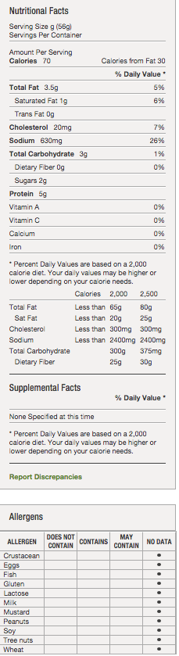
HAM
Product Description Additional Description BOILED 4 X 6 HAM. 39% ADDED INGREDIENT HAM MOLDED IN THE TRADITIONAL RECTANGULAR SHAPE. 100% USABLE. SLICE END TO END. BONELESS PRODUCT Ingredients Ham, water, dextrose, salt, carrageenan, sodiumlactate, sodium phosphates, corn starch, sodium erythorbate, sodium nitrite. Manufacturer Information PATUXENT FARMS Manufacturer Product #: 402877

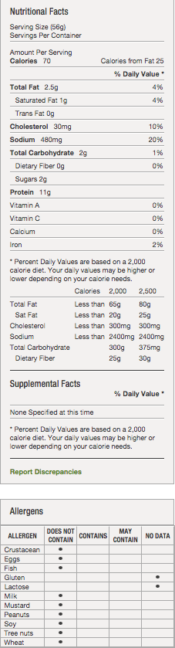
Ham, Boneless
Additional Description
ALL NATURAL, BONELESS UNCURED SMOKED BLACK FOREST HAM DELI FACED FULLY COOKED. PORK.
Ingredients
PORK, WATER, SEA SALT, VINEGAR, SUGAR, GARLIC POWDER, NATURAL FLAVOR.
Manufacturer Information
METRO DELI
Manufacturer Product #: 660853

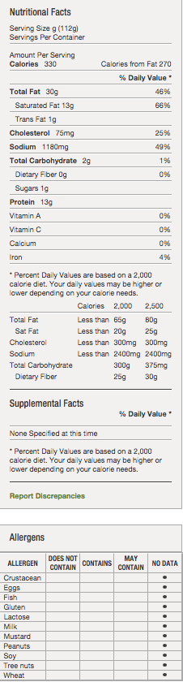
HOT DOG-BEEF
Product Description, Additional Description
OUR ALL-BEEF HOT DOGS ARE MADE FROM REAL MEAT TRIMMINGS WITH NO FILLERS, A LIGHT SMOKY FLAVOR AND A HINT OF GARLIC. GRILLED, STEAMED, BOILED OR CHAR-GRILLED, THESE ARE THE HOT DOGS YOUR CUSTOMERS WILL LOVE.
Ingredients
Beef, water, sorbitrol, salt, flavorings, sodium phosphates, sodium erythorbate, sodium nitrite, extract of paprika.
Manufacturer Information
PATUXENT FARMS
Manufacturer Product #: 412775
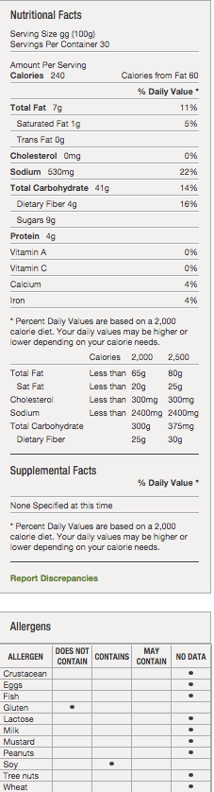
Hamburger Bun
Product Description-Additional Description
A GREAT BUN CAN TURN A BURGER INTO A MASTERPIECE. AND YES, THAT BUN CAN BE GLUTEN FREE. OUR GLUTEN FREE SEEDED HAMBURGER BUNS HAVE GREAT TASTE, SOFT TEXTURE AND NUTRITIOUS POPPY AND SESAME SEEDS. YOUR CUSTOMERS WILL SWEAR IT'S TOO GOOD TO BE GLUTEN FREE AND DAIRY FREE. KOSHER KSA. IMPORTED CANADA.
Ingredients
WATER, POTATO STARCH, TAPIOCA FLOUR, SUNFLOWER OIL, GLYCERINE, SOYA YEAST, WHOLE GRAIN RICE FLOUR, CHICKPEA FLOUR, CELLULOSE FIBER, SEA SALT, XANTHAN GUM, ORGANIC CANE SUGAR, BAKING POWDER, BAKING SODA, POPPY SEEDS, SESAME SEEDS.
Manufacturer Information
HILLTOP HEARTH
Manufacturer Product #: 441548

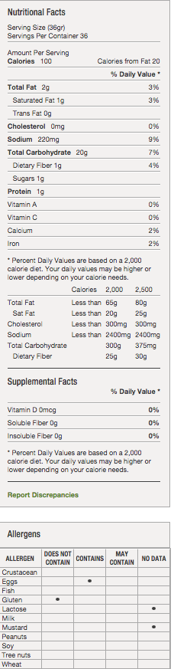
HOT DOG BUN
Product Description-Additional Description
6 GLUTEN FREE HOT DOG BUN FOR CUSTOMER REQUIRING GLUTEN FREE DIETS. PRESLICED. INDIVIDUALLY WRAPPED TO REDUCE CROSS CONTAMINATION AND ALLOW OPERATOR TO THAW ONLY PRODUCT THAT IS NEEDED
Ingredients
WATER, MODIFIED TAPIOCA STARCH, WHITE RICE FLOUR, POTATO STARCH, CORN STARCH, PALM OIL, EVAPORATED CANE JUICE,CONTAINS LESS THAN 2% OF EACH OF THE FOLLOWING: MILLET FLOUR, DRIED YEAST (YEAST, SORBITAN MONOSTEARATE), MODIFIED CELLULOSE, CANOLA OIL, SEASALT, SORGHUM FLOUR, XANTHAN GUM, GUAR GUM, RICE BRAN EXTRACT, CULTURED DEXTROSE, CALCIUM SULFATE, ENZYMES, ASCORBIC ACID
Manufacturer Information
FLOWERS FOODS SPECIALTY GROUP
Manufacturer Product #: 27019110

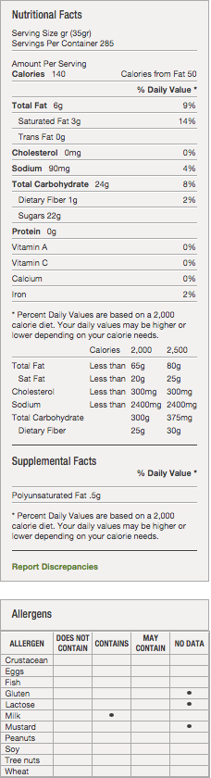
ICING, CHOCOLATE FUDGE
Product Description-Additional Description
Shelf stable and ready-to-spread chocolate fudge icing. Sweet, creamy chocolate flavor. Icing is light and airy, providing a smooth texture when spread on a finished product. 0g trans fat per serving.
Ingredients
SUGAR, PALM OIL, WATER, HIGH MALTOSE CORN SYRUP, COCOA PROCESSED WITH ALKALI, CORN STARCH. CONTAINS LESS THAN 2% OF THE FOLLOWING:HYDROGENATED PALM OIL, SALT, DISTILLED MONOGLYCERIDES, POLYSORBATE 60, POTASSIUM SORBATE (PRESERVATIVE), NATURAL AND ARTIFICIAL FLAVOR, SODIUM STEAROYL LACTYLATE, CITRIC ACID, SODIUM ACID PYROPHOSPHATE, COLOR ADDED, NONFAT MILK. CONTAINS MILK INGREDIENTS.
Manufacturer Information
GENERAL MILLS SALES INC
Manufacturer Product #: 16000-11215

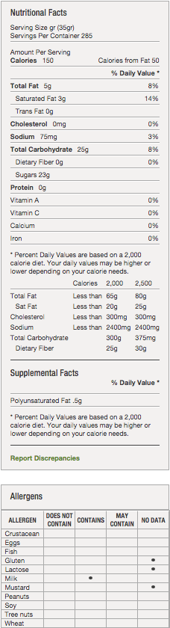
Icing-Vanilla Cream
Product Description- Additional Description
Shelf stable and ready-to-spread vanilla cream icing. Sweet, rich vanilla flavor. Icing is light and airy, providing a smooth texture when spread on a finished product. 0g trans fat per serving.
Ingredients
SUGAR, PALM OIL, WATER, HIGH MALTOSE CORN SYRUP, CORN STARCH. CONTAINS LESS THAN 2% OF THE FOLLOWING: HYDROGENATED PALM OIL, SALT,DISTILLED MONOGLYCERIDES, YELLOWS 5 & 6 AND OTHER COLOR ADDED, POLYSORBATE 60, POTASSIUM SORBATE AND CITRIC ACID (PRESERVATIVES), SODIUM STEAROYL LACTYLATE, SODIUM ACID PYROPHOSPHATE, NATURAL AND ARTIFICIAL FLAVOR, NONFAT MILK. CONTAINS MILK INGREDIENTS.
Manufacturer Information
GENERAL MILLS SALES INC
Manufacturer Product #: 16000-11216

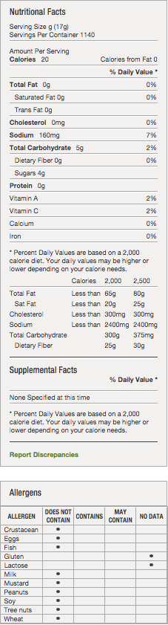
Ketchup
Product Description-Additional Description
EXCLUSIVE US FOODS SPICE FORMULA WITH 33% TOMATO SOLIDS. SAME EXACT PRODUCT AS OUR MONARCH BOTTLE KETCHUP. FANCY GRADE, PACKED FROM TOMATO CONCENTRATE. FREE PUMP INCLUDED WITH EVERY CASE. KOSHER U.
Ingredients
TOMATO CONCENTRATE, HIGH FRUCTOSE CORN SYRUP, VINEGAR, CORN SYRUP, SALT, ONION POWDER, SPICE, NATURAL FLAVORS.
Manufacturer Information
MONARCH
Manufacturer Product #: 165056

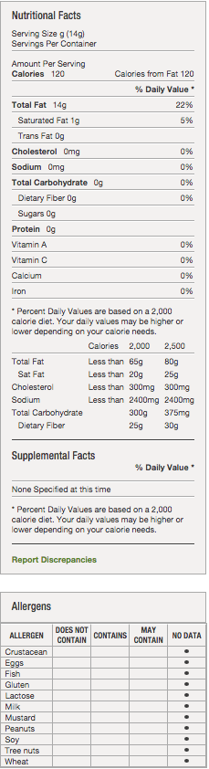
OIL, CANOLA EXTRA VIRGIN OLIVE
Product Description- Additional Description
CANOLA 90% AND EXTRA VIRGIN OLIVE OIL 10% BLEND. SHELF LIFE 9 MONTHS.
Ingredients
CANOLA OIL, EXTRA VIRGIN OLIVE OIL.
Manufacturer Information
ROSELI
Manufacturer Product #: 291563

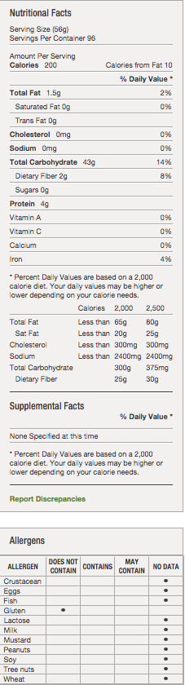
Pasta, GLUTEN FREE Penne
Product Description-Additional Description
MADE WITH WHOLE GRAIN BROWN RICE, THIS GLUTEN FREE PASTA IS AL DENTE AND LOOKS, COOKS AND TASTES JUST LIKE REGULAR PASTA. NOW YOU CAN GIVE YOUR FAVORITE ITALIAN RECIPES A GLUTEN FREE TOUCH. KOSHER COR.
Ingredients
BROWN RICE, RICE BRAN, AND WATER.
Manufacturer Information
MONARCH
Manufacturer Product #: 444219

REGULAR PASTA
ROSELI'S PENNE RIGATE IS PASTA YOU CAN COUNT ON TO MAKE YOUR ITALIAN-INSPIRED DISHES THE BEST, EVERY TIME. IT'S MADE FROM THE BEST DURUM SEMOLINA, SELECTED FROM NO. 1 AMBER DURUM WHEAT SOWN AND HARVESTED FOR OPTIMUM COOKING QUALITY. KOSHER PAREVE.
Ingredients
SEMOLINA, ENRICHED WITH IRON (FERROUS SULFATE) AND B VITAMINS (NIACIN, THIAMIN MONONITRATE, RIBOFLAVIN, FOLIC ACID).
Manufacturer Information
ROSELI
Manufacturer Product #: 210024

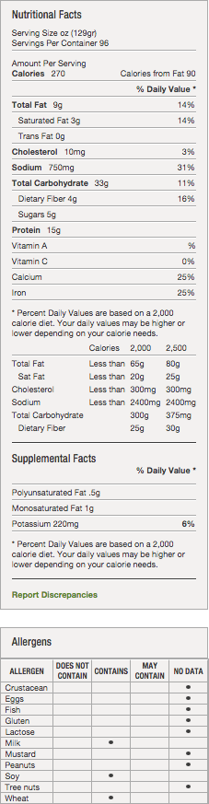
PIZZA, CHS-PERSONAL
Product Description-Additional Description
Traditional 4x6 school pizza provides 2 equivalent grains and 2 meat/meat alternates, 1/8 cup veg. Made with 51% Whole grain.
Ingredients
WATER, WHOLE WHEAT FLOUR, ENRICHED WHEAT FLOUR (BLEACHED WHEAT FLOUR, MALTED BARLEY FLOUR, NIACIN, REDUCED IRON, THIAMINE MONONITRATE, RIBOFLAVIN, FOLIC ACID), MOZZARELLA CHEESE (PASTEURIZED PART SKIM MILK, CHEESE CULTURES, SALT, ENZYMES), SOY FLOUR, TOMATO PASTE (NOT LESS THAN 31% NTSS), SOYBEAN OIL, LESS THAN 2% OF: CASEIN, MILK PROTEIN CONCENTRATE, PIZZA SEASONING (SALT, SUGAR, SPICES, DEHYDRATED ONION, GUAR AND XANTHAN GUM, GARLIC POWDER, POTASSIUM SORBATE, CITRIC ACID), MODIFIED CORN STARCH, BAKING POWDER (SODIUM BICARBONATE, SODIUM ALUMINUM SULFATE, CORNSTARCH, MONOCALCIUM PHOSPHATE, CALCIUM SULFATE), DEXTROSE, SALT, MODIFIED POTATO STARCH, DOUGH CONDITIONER (WHEAT FLOUR, SALT, SOY OIL, L. CYSTEINE, ASCORBIC ACID, ENZYME) AND/OR WHEAT GLUTEN, SODIUM ALUMINUM PHOSPHATE, DISODIUM PHOSPHATE, MOZZARELLA CHEESE TYPE FLAVOR (MOZZARELLA CHEESE [MILK, CULTURE, RENNET, SALT], MILK SOLIDS, DISODIUM PHOSPHATE), LACTIC ACID, SORBIC ACID, NUTRIENT BLEND (MAGNESIUM OXIDE, ZINC OXIDE, CALCIUM PANTOTHENATE, RIBOFLAVIN AND VITAMIN B-12), VITAMIN A PALMITATE, SOY LECITHIN. CONTAINS:MILK, SOY, WHEAT.
Manufacturer Information
CONAGRA FOODS SALES LLC
Manufacturer Product #: 7738712655

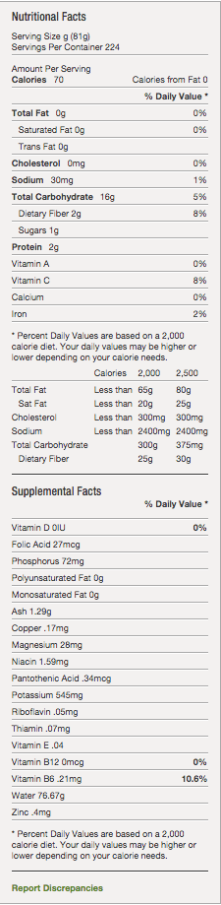
Potato
Additional Description
5/8" X 5/8" X 3/4" DICED POTATOES HAVE BEEN BLANCHED AND REFRIGERATED TO PROVIDE AN EXTENDED SHELF LIFE. THESE CAN BE USED FOR SOUPS, POTATO SALAD OR SAUTEED FOR A QUICK POTATO SIDE, IN ADDITION TO ANY NUMBER OF OTHER APPLICATIONS, WHERE LITTLE PREP WORK IS NEEDED.
Ingredients
POTATOES, DEXTROSE, DISODIUM PYROPHOSPHATE (ADDED TO MAINTAIN COLOR), POTASSIUM SORBATE (ADDED TO MAINTAIN FRESHNESS).
Manufacturer Information
CROSS VALLEY FARMS
Manufacturer Product #: 031007
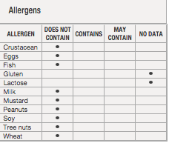

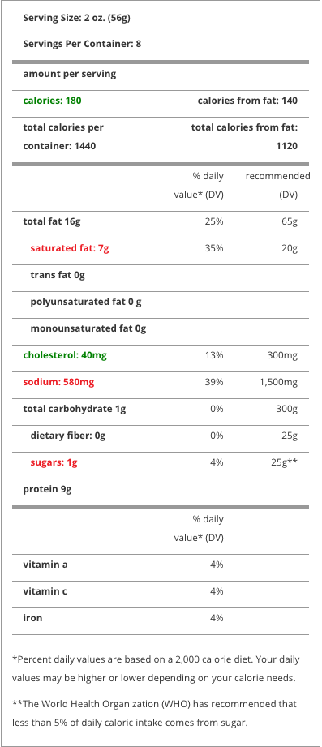PORK ROLL-Pork roll/Taylor ham is a processed pork product made with a mix of spices, salt, a sugar cure, and preservatives that is smoked before being packaged.

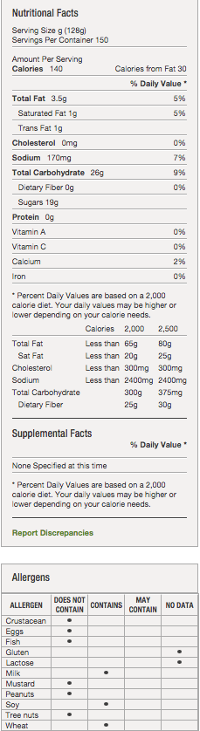

Pudding, Vanilla
Product Description-Additional Description
24-1/2 CUP SERVINGS PER CAN, READY TO USE.
Ingredients
WATER, SUGAR, SKIM MILK, MODIFIED FOOD STARCH, LACTOSE, PARTIALLY HYDROGENATED SOYBEAN OIL, SALT, SODIUM STEAROYL LACTYLATE, ARTIFICIAL VANILLA FLAVORS, XANTHAN GUM, COLOR ADDED (INCLUDING FD&C YELLOW 5 AND FD&C YELLOW 6.
Manufacturer Information
HARVEST VALUE
Manufacturer Product #: 281326

PRETZELS - Rold Gold Classic Tiny Twists
Ingredients
ENRICHED FLOUR (WHEAT FLOUR, NIACIN, REDUCED IRON, THIAMIN MONONITRATE, RIBOFLAVIN, FOLIC ACID), SALT, CORN OIL, CORN SYRUP, AMMONIUM BICARBONATE, MALT EXTRACT, AND YEAST.
Manufacturer Information
FRITO LAY/ QUAKER/ TROPICANA - Manufacturer Product #: 37679

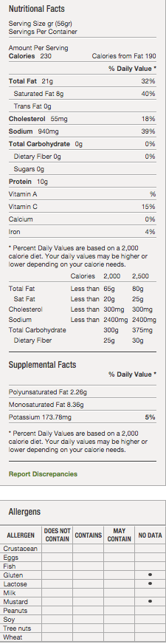
SALAMI
Product Description -Additional Description AGED TO PERFECTION FOR SUPERIOR FLAVOR AND SLICEABILITY DELICATE BLEND OF MANY FLAVORS EASY PEEL CASING FOR CONVENIENCE CONSISTENT IN FLAVOR, COLOR, AND DRYNESS BLUNT ENDS FOR MAXIMUM SLICING YIELD Ingredients INGREDIENTS: PORK, BEEF, SALT, CONTAINS 2% OR LESS OF DEXTROSE, SPICES, LACTIC ACID STARTER CULTURE, SODIUM ASCORBATE, GARLIC POWDER, SODIUM NITRITE, BHA, BHT, CITRIC ACID. Manufacturer Information HORMEL FOODS CORPORATION Manufacturer Product #: 40634

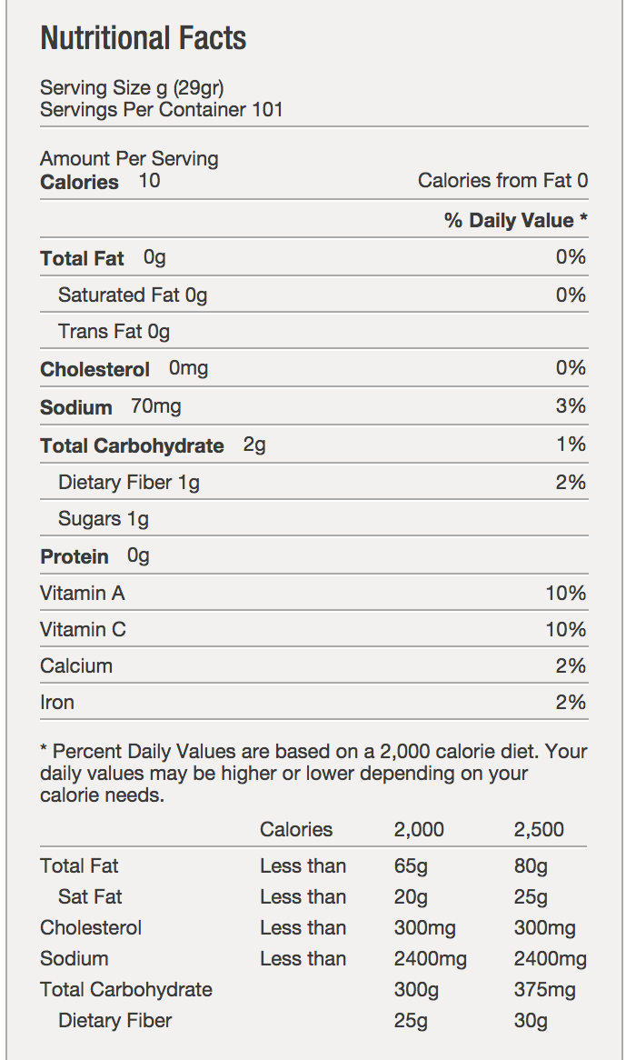
SALSA (mild)

Ingredients
TOMATO PUREE, DICED TOMATOES IN TOMATO JUICE, JALAPENOS, VINEGAR, CONTAINS LESS THAN 2% OF: DEHYDRATED ONION, SALT, SEA SALT, NATURAL FLAVORS, SUGAR, DEHYDRATED GARLIC, VITAMIN C (ASCORBIC ACID), SPICES, VITAMIN E (DL-ALPHA TOCOPHERYL ACETATE), VITAMIN A (RETINOL PALMITATE).

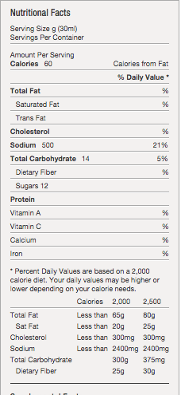

Sauce, Barbecue Hickory
Product Description-Additional Description
MONARCH'S MEDIUM-BODIED BBQ SAUCE ADDS A SMOKY NOTE OF HICKORY TO YOUR GRILLED MASTERPIECES. WITH JUST THE RIGHT BALANCE OF FLAVOR FROM TOMATO PASTE, VINEGAR, HICKORY SMOKE AND SPICES, IT'S PERFECT AS FINISHING SAUCE, DIP, MARINADE OR CONDIMENT.
Ingredients
WATER, HIGH FRUCTOSE CORN SYRUP, SUGAR, TOMATO PASTE, DISTILLED AND CIDER VINEGAR, SALT, MODIFIED FOOD STARCH, SPICES, NATURAL SMOKE FLAVOR, ONION*, GARLIC*, PAPRIKA, CARAMEL COLOR, NATURAL FLAVOR, SODIUM BENZOATE (A PRESERVATIVE), *DEHYDRATED.
Manufacturer Information
MONARCH
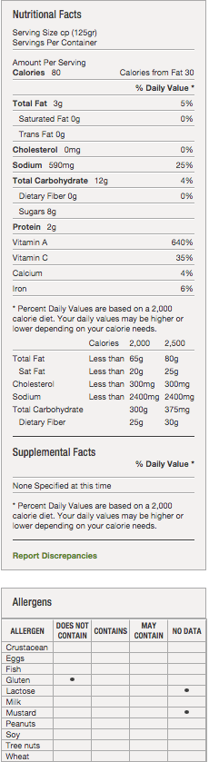
Manufacturer Product #: 919085

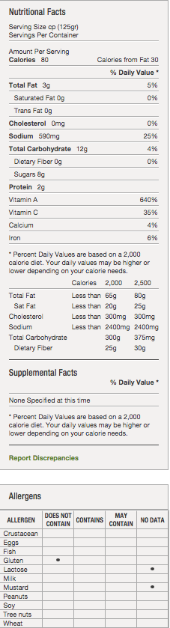

Sauce, Marinara
Product Description-Additional Description
"FULL RED(R) MARINARA'S SUBTLE SEASONINGS ALLOW THE FRESH TOMATO FLAVOR TO COME THROUGH (THE SIGN OF A REAL ITALIAN MARINARA!). AND BECAUSE IT'S LIGHTLY SEASONED, IT'S IDEAL FOR RESTAURATEURS WHO LIKE TO ADD A BIT OF THEIR OWN SEASONINGS FOR A SPECIAL ""SIGNATURE""."
Ingredients
VINE-RIPENED FRESH TOMATOES, BLEND OF EXTRA VIRGIN OLIVE OIL AND SUNFLOWER OIL, SALT, ONIONS, SUGAR, BLACK PEPPER, BASIL, OREGANO, PARSLEY, AND NATURALLY DERIVED CITRIC ACID.
Manufacturer Information
STANISLAUS FOODS PRODUCTS CO.
Manufacturer Product #: 01704

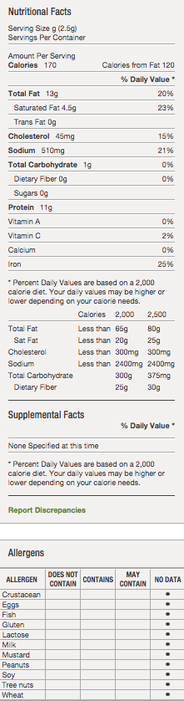

SAUSAGE Product Description Additional Description MILD AND SWEET, OUR RAW PORK SAUSAGE IS FLAVORED PERFECTLY WITH SALT, PEPPER, GARLIC AND FENNEL AND IS READY TO BE ADDED TO ANY RECIPE. Ingredients Pork, water, salt, spices, BHA, BHT, citric acid. Manufacturer Information ROSELI Manufacturer Product #: 412750

SOY NUT BUTTER
A nutritious substitute for peanut butter 100% free of peanuts and tree nuts. Safe for anyone allergic to peanuts, tree nuts, eggs, dairy and gluten USDA meat alternative: 2 tbl = 1 oz meat alternative
Ingredients- NON GMO ROASTED SOYBEANS, NATURALLY PRESSED SOYBEAN OIL, MALTODEXTRIN, GRANULATED CANE SUGAR, PALM OIL, SALT

SOY NUT BUTTER COMPANY - Manufacturer Product #: 80001

TORTILLA CHIPS
Doritos deliver a powerful crunch that unlocks the bold and unique flavors you crave.
Ingredients: CORN, VEGETABLE OIL (CORN, SUNFLOWER, AND/OR CANOLA), AND SALT.

Manufacturer Information- FRITO LAY/ QUAKER/ TROPICANA- Manufacturer Product #: 47752

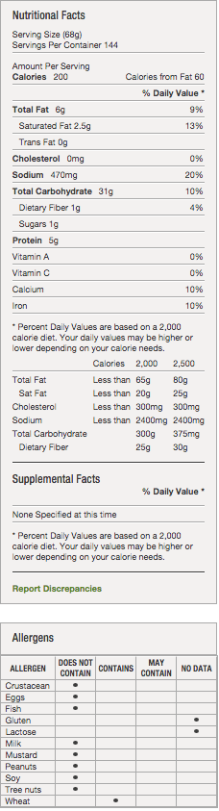
TORTILLA, FLOUR
Product Description-Additional Description
KOSHER PAREVE. SOFT, TENDER MOUTHFEEL AND TEXTURE. STRONG, YET FLEXIBLE. TORTILLA HAS DARK BROWN TOAST POINTS THAT RELEASE BREAD-LIKE AROMAS WHEN HEATED OR WARMED OVER AN OPEN FLAME.
Ingredients
ENRICHED BLEACHED WHEAT FLOUR (FLOUR, NIACIN, REDUCED IRON, THIAMIN MONONITRATE, RIBOFLAVIN, FOLIC ACID), WATER, VEGETABLE SHORTENING (INTERESTERIFIED SOYBEAN OIL, FULLY HYDROGENATED SOYBEAN OIL), CONTAINS 2% OR LESS OF THE FOLLOWING: SALT, MONO AND DIGLYCERIDES, DEXTROSE, LEAVENING (SODIUM BICARBONATE, SODIUM ALUMINUM PHOSPHATE, SODIUM ALUMINUM SULFATE), FUMARIC ACID, YEAST, PRESERVATIVES (CALCIUM PROPIONATE, POTASSIUM SORBATE), CORN STARCH, CARBOXYMETHYL GUM, WHEAT STARCH, XANTHAN GUM, ENZYMES (WHEAT STARCH, MICROCRYSTALLINE CELLULOSE), DOUGH CONDITIONER (SODIUM METABISULFITE)
Manufacturer Information
DEL PASADO
Manufacturer Product #: 002726

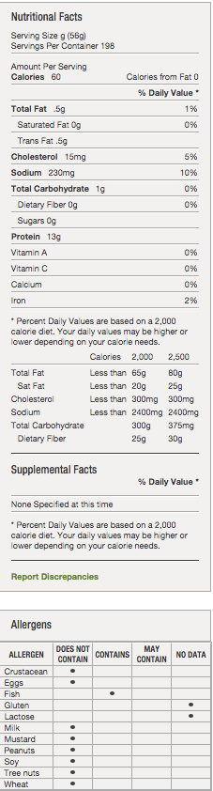
TUNA
Product Description-Additional Description
TONGOL TUNA IS THE SMALLEST OF THE LIGHT MEAT FISHES. IT IS HAS A FIRM TEXTURE AND MILD FLAVOR. PACKED AS TUNA WATER AND SALT WITH VEGETABLE BROTH AND IS PACKED TO A PRESS WEIGHT OF 37.9 OUNCES. PACKED IN THAILAND, VIETNAM AND INDONESIA. KOSHER.
Ingredients
TONGOL TUNA, WATER, VEGETABLE BROTH, SALT.
Manufacturer Information
MONARCH
Manufacturer Product #: 151334

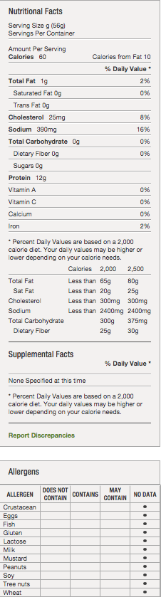
TURKEY BREAST
Additional Description
TURKEY, BREAST WHOLE MUSCLE UNSLICED SKIN-ON COOKED OVEN ROASTED REF 4-DIAMOND. 4 DIAMOND = ALL NATURAL DELI STYLE PAN ROASTED TURKEY BREAST. SKIN-ON WHOLE MUSCLE PRODUCT WITH NO ADDED STARCHES OR GUMS. BEST FOR CARVING APPLICATIONS.
Ingredients
TURKEY BREAST, TURKEY BROTH, SALT, DEXTROSE, SODIUM PHOSPHATE.
Manufacturer Information
PATUXENT FARMS
Manufacturer Product #: 2265591050

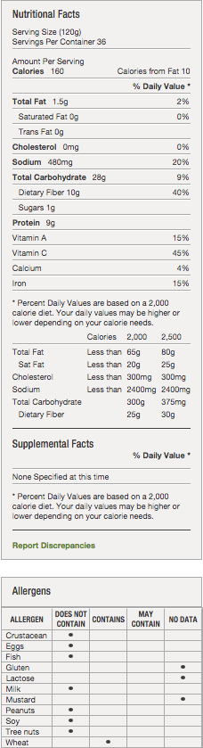
VEGGIE BURGER
Additional Description
A RICH AND SPICY BLACK BEAN VEGGIE BURGER CONSISTING OF A BLACK BEANS, ROLLED OATS, PEPPERS AND VARIOUS SPICES IN A TRADITIONAL BURGER SHAPE. THIS BURGER IS KOSHER AND VEGETARIAN, MAKING IT A DELICIOUS AND NUTRITIOUS MEAL OR ANYTIME ALTERNATIVE TO OTHER BURGERS.
Ingredients
BLACK BEANS (COOKED BLACK BEANS, WATER), WATER, RED BELL PEPPER, BLACK BEAN MIX (BLACK BEAN FLAKES, DEHYDRATED ONION, LESS THAN 2% OF ORGANIC EXPELLER PRESSED CANOLA OIL, SALT, CUMIN, CHILI PEPPER, DEHYDRATED GARLIC, OREGANO, CORIANDER, CINNAMON, ALLSPICE, BLACK PEPPER), GREEN PEPPER, ROLLED OATS, CAYENNE PEPPER SAUCE (AGED CAYENNE PEPPERS, DISTILLED VINEGAR, WATER, SALT, NATURAL FLAVOR, AND GARLIC POWDER), BREAD CRUMBS (WHEAT FLOUR, SUGAR, YEAST, SALT), CILANTRO, PARSLEY, SALT, GROUND CUMIN SEEDS, GARLIC POWDER, CHIPOTLE PEPPERS IN ADOBO SAUCE (CHIPOTLE PEPPERS, WATER, VINEGAR, SUGAR, SALT, TOMATO PASTE, SMOKE ESSENCE, ONION, GARLIC), GROUND BLACK PEPPER.
Manufacturer Information
CHEF'S LINE
Manufacturer Product #: 540672

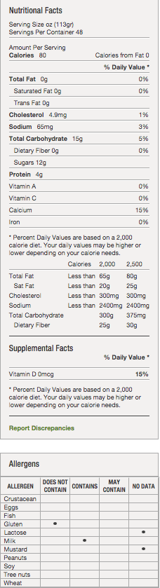
Yogurt, Strawberry, Banana Blend
Product Description-Additional Description
DANIMALS CRUSH CUP YOGURT IS A TOP SELLING KIDS BRAND. IT DELIVERS GREAT NUTRITION IN A KID FRIEND PACKAGE. IT'S A GREAT SOURCE OF PROTEIN, CALCIUM AND VITAMIN D. NO ARTIFICIAL COLORS, NO ARTIFICIAL FLAVORS, NO HIGH FRUCTOSE CORN SYRUP.
Ingredients
CULTURED GRADE A NON FAT MILK, SUGAR, WATER, MODIFIED FOOD STARCH, CONTAINS LESS THAN 1% OF KOSHER GELATIN, NATURAL FLAVORS, BETA CAROTENE AND VEGETABLE JUICE (FOR COLOR), AGAR AGAR, SODIUM CITRATE, MALIC ACID, POTASSIUM SORBATE (TO MAINTAIN FRESHNESS), VITAMIN D3. *1 MEAT/ MEAT ALTERNATIVE , **ALLERGEN: MILK ***CHOLESTEROL IS
Manufacturer Information
DANNON COMPANY INC
Manufacturer Product #: 2732

SLUSHIES

High Fructose Corn Sweetener, Water, Citric Acid, Modified Food Starch, Natural and Artificial Flavors, Glycerl Abietate, 1/10th of 1% Sodium Benzoate as Preservative, various food coloring- Blue #1, Red #20, etc.

